Using the ENA+R R console plug-in

Requirements
In order to run the plug-in you will need the following components installed on your system
- EwE version 6.3 or newer
- EwENetworkAnalysisR plug-in
- R
- enaR package for R

Configuring the plug-in
In EwE, with the ENA+R plug-in loaded, navigate to ‘Menu > Tools > Execute NETWRK (R)’ (Fig 1). This brings up the ‘Execute NETWRK (R)’ console (Fig 2).
This console is built for debugging purposes. Currently, users must enter the following values:
- The full path to the R executable
- The full path to the R script to execute
- A file placeholder that will be used to substitute the full path to the SCOR file as written by EWE into the R script. In this example, the R script contains the line
file.name="%SCORFILE%"
that is set up to receive the actual location of the SCOR file. Note that the code automatically will convert Windows path formats to the UNIX file path format preferred by R.
- Lastly, a fixed location of the SCOR file that EwE must produce can be entered. If left empty, EwE will write the SCOR file to a temporary file in the Windows temp folder.
Note that these values have to be entered once; they will reappear the next time you open the console.

Running R
Currently, the R script is executed explicitly when users click the [Run] button. Once R has ran, the plug-in will display R runtime information:
- The script that was sent to R (Fig 3, note the substituted file name);
- R output data (Fig 4, here shown without results because there were errors);
- R error information (Fig 5).

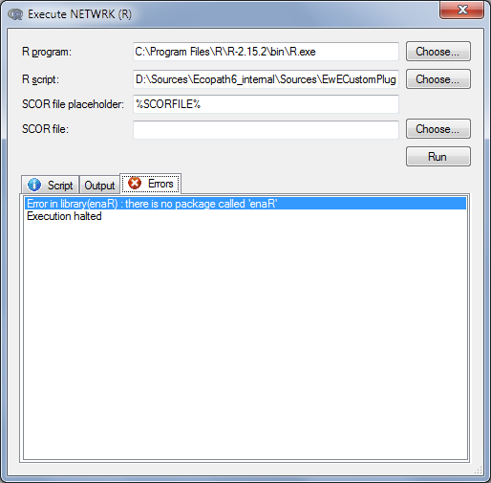
Fig 5 – R errors
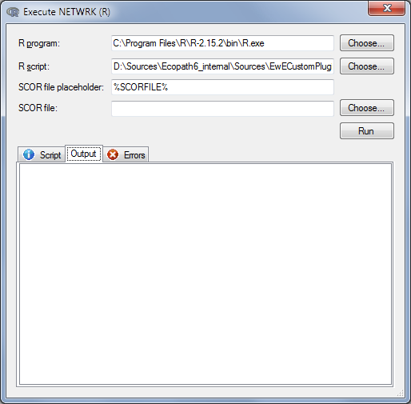
Fig 4 – R output
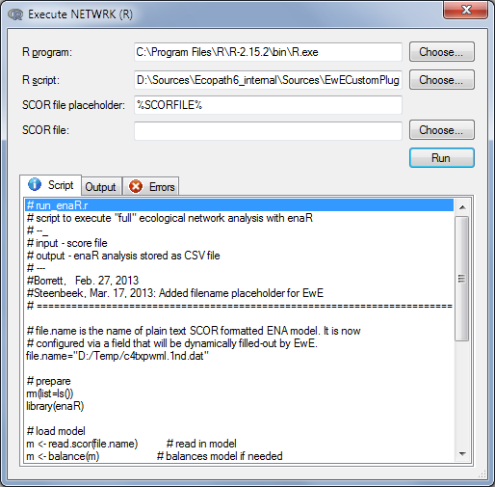
Fig 3 – R script
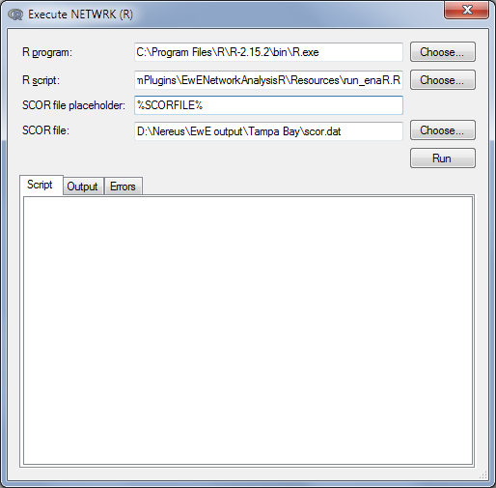
Fig 2 – Plug-in console

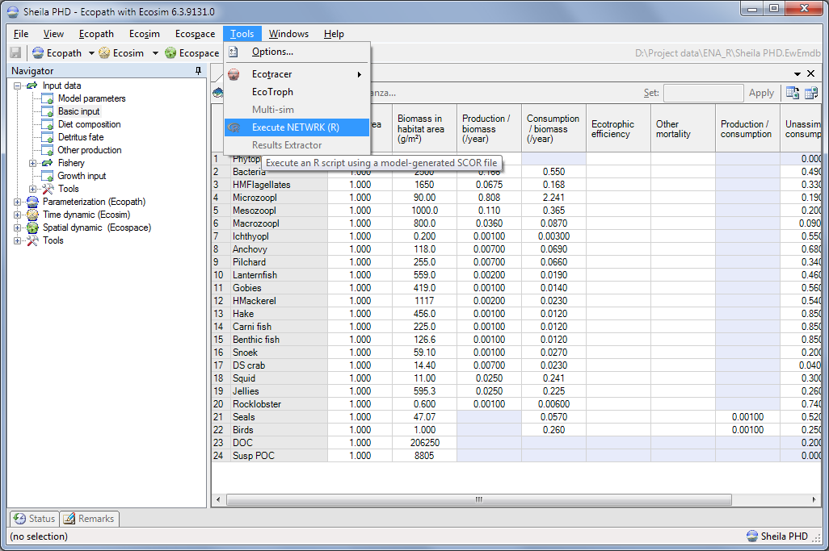
Fig 1 - NETWRK plug-in location

